**Year 2 Homework Menu - Spring Term**

**Reading**

There are comprehensions for you to do each week. Make sure to mark it in your reading log so you get extra dojos.



**DT/Art**

Choose a recipe with your grown up and follow it to create a yummy dish. Take pictures and tell us what you think.

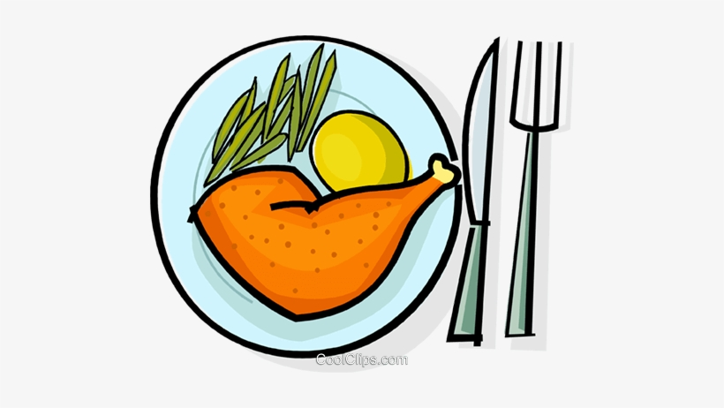

**Maths**

Maths worksheet will be uploaded weekly.

Also, remember to go on TT Rockstars.



**Writing**

Using the picture as a stimulus write a story about the picture. There are some extra activities to get you started.



**PHSE**

Keep a diary for a week about the healthy choices you make and what you do to relax.

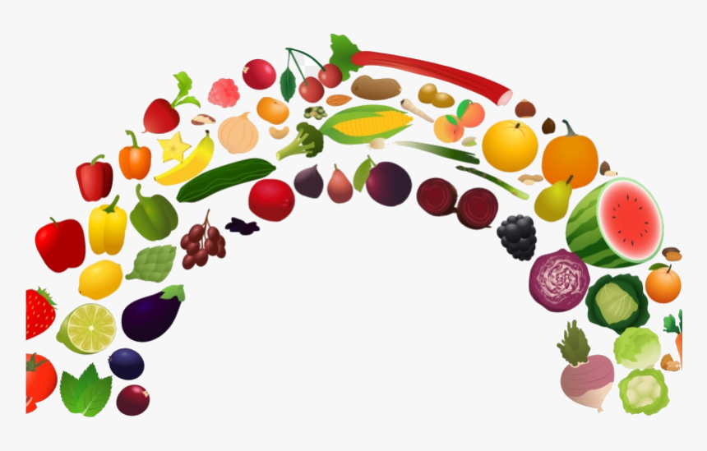

**Geography Experience**

Chose one city in the UK and create a fact file about it. Think about what can you see/do there? Are there any special celebrations? Are there any rivers or mountains?

**Science**

Go on a walk and find as many habitats as you can.

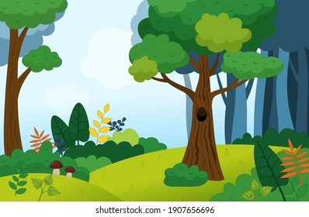

**Speaking & Listening**

Interview somebody about what it was like when they grew up? What toys did they play with? How did they travel? How did they talk to people?



**Music**

Use this link

<https://www.youtube.com/watch?v=l-dYNttdgl0>

Listen very carefully to the music and complete the tasks listed.



**PE**

Create a game that only involves one ball. Write down the rules and instructions on how to play. Maybe have a go at playing it with a grown up or sibling.



**Bronze Award = 5 Silver Award = 8 Gold Award = 10 Platinum Award = 10 + 2 challenges**